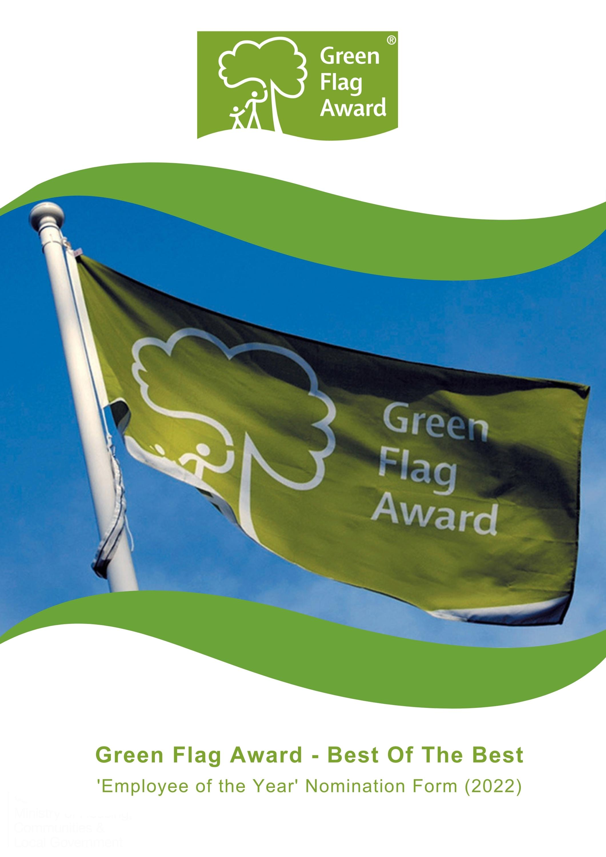

The Green Flag Award Scheme is the UK standard for parks and green spaces. The Scheme is delivered in the UK by Keep Britain Tidy, Keep Northern Ireland Beautiful, Keep Scotland Beautiful and Keep Wales Tidy.
To highlight the amazing work that takes place in our award-winning green spaces we are celebrating the ‘Best of the Best’ in our annual virtual award ceremony this November.
Nominees will be shortlisted in October 2022 and the winner will be announced during the virtual award ceremony, on Tuesday 15th November 2022.

Award Category: Employee of the Year
Eligibility
Any park / green space employee who works in a UK Green Flag Award park or green space. e.g. gardener, ranger, volunteer co-ordinator, visitor centre staff, manager etc.
Who can be nominated?
To be eligible for an award, the member of staff must work for and be endorsed by the organisation for which they work.
Who can nominate?
Any organisation is entitled to nominate any number of members of staff.
Criteria
The following criteria will be considered by the selection panel:
- Scope of the work undertaken and the outcome of their work
- Initiative and innovation demonstrated by the member of staff
- Impact and benefit the individual has made in the course of their work
- Any obstacles which the nominee may have had to overcome to achieve the outcomes of their work.
Nominations must be submitted electronically and address the criteria for the award. Organisations may nominate more than one member of staff
Nominees must agree to any media publicity and promotion associated with the award as requested by The Green Flag Award Scheme and or Keep Britain Tidy and their partners.
Selection Panel
Nominations will be assessed by an independent selection panel chaired by the Green Flag Award Team.
The judges reserve the right not to confer an award.

Award
The panel will award a winner, or in a tie, may award joint winners of the award. In exceptional circumstances the panel may confer a special commendation.
Feedback
The selection panel will provide feedback for the winner of the award. No feedback will be provided to unsuccessful applications
If you would like to send us supporting evidence such as reference materials, photos, screen grabs or press cuttings, please send these with the completed application form to greenflagawards@keepbritaintidy.org
CLOSING DATE FOR ENTRIES: Friday 30th September by 5pm

Part One:
Project and applicant Information
Name of nominated employee

Contact details of nominated employee
Name, address, tel, email

Name and contact details of person and organisation nominating the employee

Name of Green Flag Award site

Please complete each of the sections below, using maximum 500 words per section and identify any supporting evidence you are submitting.

Part Two:
Application Details
What work did the employee undertake and what did they achieve?
(Maximum 500 words, please identify any supporting evidence you are submitting.)

Tell us about initiative and innovation demonstrated by the employee.
(Maximum 500 words, please identify any supporting evidence you are submitting.)

Describe what impact and benefit the individual has made in the course of their employment.
(Maximum 500 words, please identify any supporting evidence you are submitting.)

Tell us about any obstacles which the nominee may have had to overcome to achieve the outcomes of their work.
(Maximum 500 words, please identify any supporting evidence you are submitting.)

Thank you for submitting your application.

