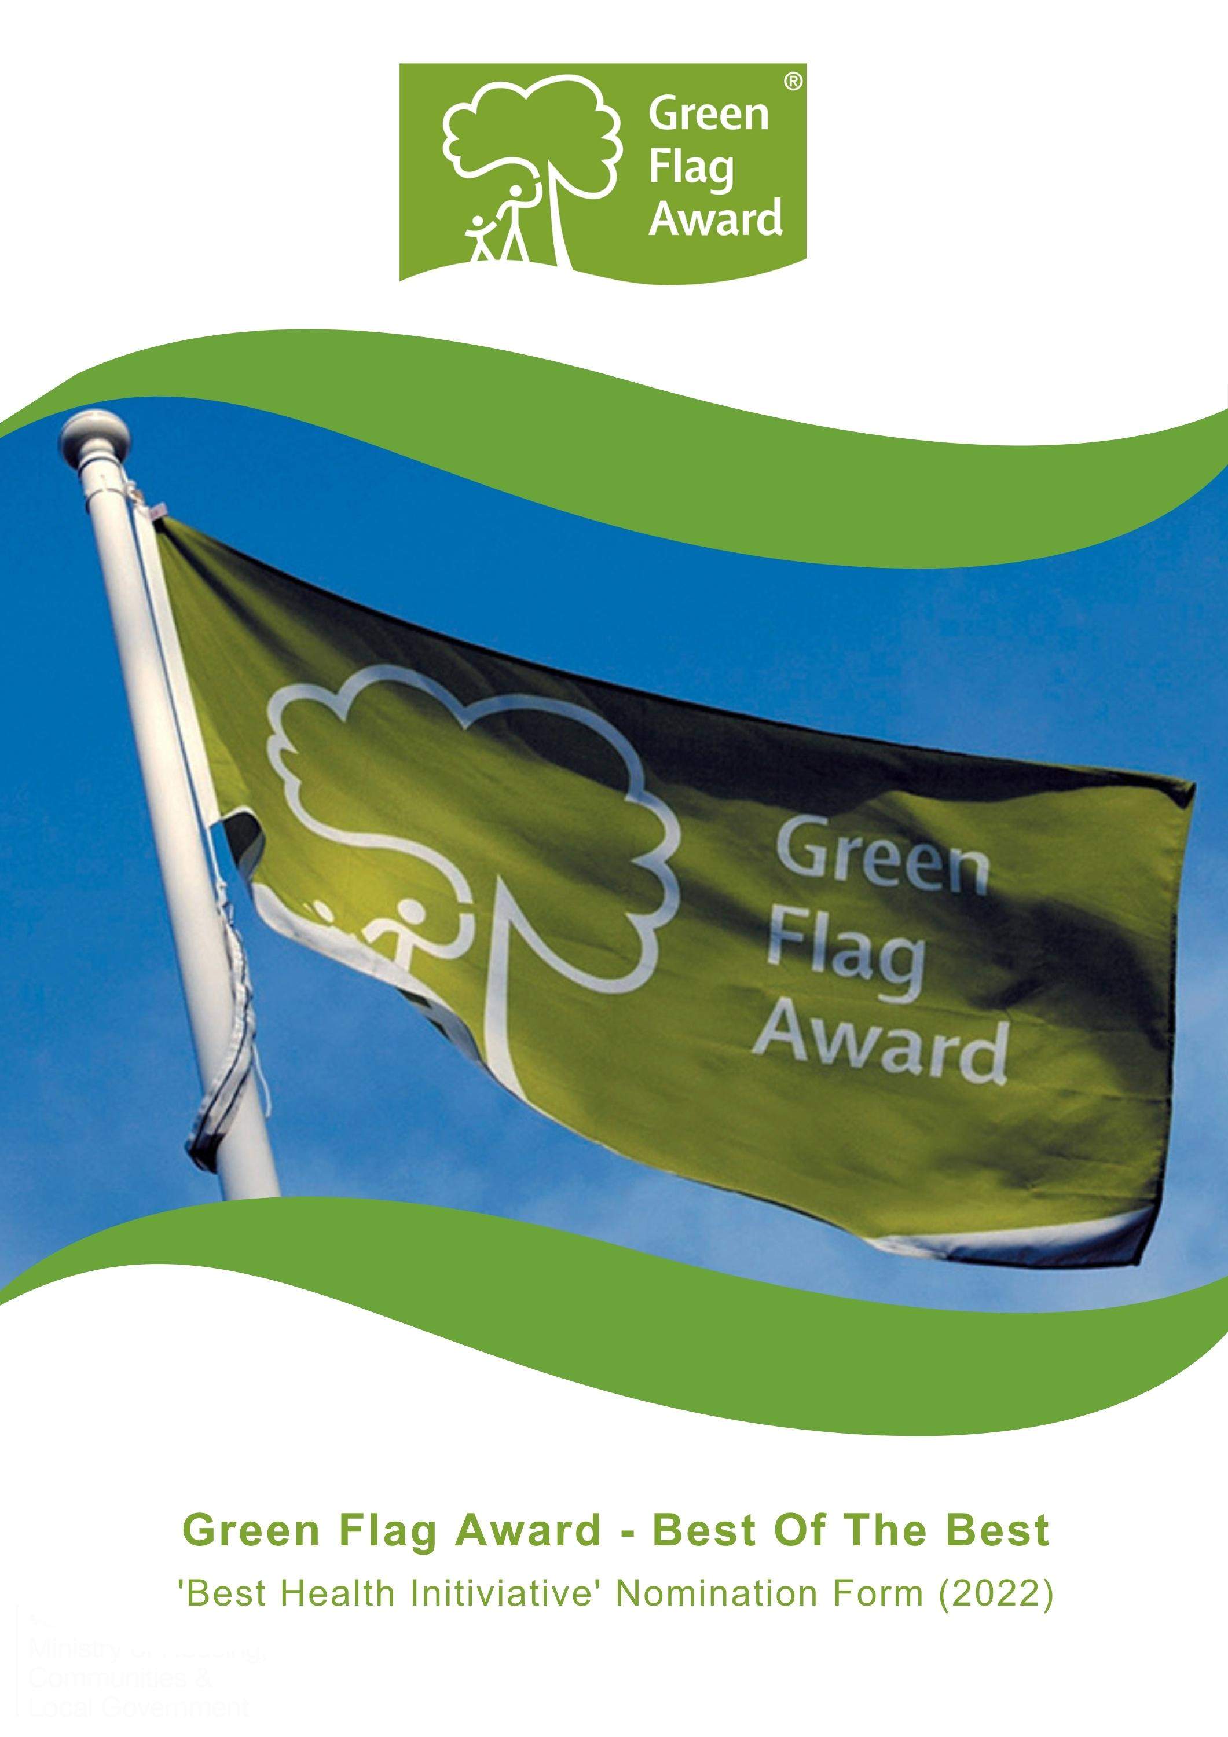

The Green Flag Award Scheme is the UK standard for parks and green spaces. The Scheme is delivered in the UK by Keep Britain Tidy, Keep Northern Ireland Beautiful, Keep Scotland Beautiful and Keep Wales Tidy.
To highlight the amazing work that takes place in our award-winning green spaces we are celebrating the ‘Best of the Best’ in our annual virtual award ceremony this November
Nominees will be shortlisted in October 2022 and the winner will be announced during the virtual award ceremony, on Tuesday 15th November 2022.

Award Category: Best Health Initiative of the Year
Eligibility
Any one of the Green Flag Award or Green Flag Community Award winning sites in the UK can apply for this award. The application must be submitted by the management team of the space.
Criteria
The following criteria will be considered by the selection panel:
- Any initiative, event, provision structural or otherwise that has been developed and implemented to support the physical or mental health of the community which it serves
- The identification of needs and the benefits achieved, including numbers will be considered
- The sustainability, scalability and replicability of the initiative will be considered
- Innovative and new ideas
- Nominations must be submitted electronically and address the criteria for the award. Organisations may nominate more than one initiative. Please complete a separate nomination form for each initiative.
Applicants must agree to any media publicity and promotion associated with the award as requested by The Green Flag Award Scheme and or Keep Britain Tidy and their partners.

Selection Panel
Applications will be assessed by an independent selection panel chaired by the Green Flag Award Team.
The judges reserve the right not to confer an award.
Award
The panel will award a winner, or in a tie, may award joint winners of the award. In exceptional circumstances the panel may confer a special commendation.
Feedback
The selection panel will provide feedback for the winner of the award. No feedback will be provided to unsuccessful applications
If you would like to send us supporting evidence such as reference materials, photos, screen grabs or press cuttings, please send these with the completed application form to greenflagawards@keepbritaintidy.org
CLOSING DATE FOR ENTRIES: Friday, 30th September by 5pm

Part One:
Project and applicant Information
Name and contact details of person completing the application

Name of Green Flag Award site

Date the initiative was launched/implemented?

How often is the initiative run (if not structural)?

Please complete each of the sections below, using maximum 500 words per section and identify any supporting evidence you are submitting.

Part Two:
Application Details
Please describe the initiative?
(Maximum 500 words, please identify any supporting evidence you are submitting.)

For what purpose was the initiative developed? E.g physical or mental health improvement? Which groups within the community does it target?
(Maximum 500 words, please identify any supporting evidence you are submitting.)

Describe what impact and benefit the initiative has made to the community.
(Maximum 500 words, please identify any supporting evidence you are submitting.)

Approximately how many members of the community have benefitted from the initiative to date?
(Maximum 500 words, please identify any supporting evidence you are submitting.)

Thank you for submitting your application.

