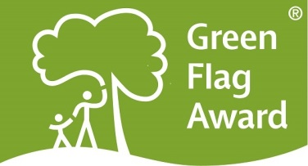
Green Flag Award
Volunteer of the Year
Nomination Form

The Green Flag Award Scheme is the UK standard for parks and green spaces. The Scheme is delivered in the UK by Keep Britain Tidy, Keep Northern Ireland Beautiful, Keep Scotland Beautiful and Keep Wales Tidy. The Volunteer of the Year will be announced in July 2018.

Award Category: Green Flag Award Volunteer of the Year
This award category is open to nominate volunteers who have been involved in one of the Green Flag Award winning sites in the UK. To be eligible for an award, the volunteer must be endorsed by the organisation for which they volunteer. There will be a winner announced for England, Northern Ireland, Scotland and Wales.

The following criteria will be considered by the selection panel:
- scope of the work undertaken and the outcome of their volunteer achievement
- initiative and innovation demonstrated by the volunteer
- how the individual has made a difference in the course of their volunteering
- any obstacles which the volunteer may have had to overcome to achieve the outcomes of their work
Any individual is entitled to nominate any number of volunteers. However, any nomination must be endorsed by the organisation for which the person volunteers. If you would like to send us supporting evidence such as reference materials, photos, screen grabs or press cuttings, please send these to greenflagawards@keepbritaintidy.org
If you have any questions, or would like help completing your application, please contact us at greenflagawards@keepbritaintidy.org
CLOSING DATE FOR ENTRIES: 25th June 2018

Part One:
Project and applicant Information
Name of nominated volunteer
Contact details of nominated volunteer
Name, address, tel, email
Name and contact details of person nominating the volunteer
Name of Green Flag Award site
Name of person and organisation endorsing the nomination (if different to person making the nomination)

Please complete each of the sections below, using maximum 500 words per section and identify any supporting evidence you are submitting.

Part Two:
Application Details
What work did the volunteer undertake and what did they achieve?
(Maximum 500 words, please identify any supporting evidence you are submitting.)

Tell us about initiative and innovation demonstrated by the volunteer.
(Maximum 500 words, please identify any supporting evidence you are submitting.)

Describe what impact and benefit the individual has made in the course of their volunteering.
(Maximum 500 words, please identify any supporting evidence you are submitting.)

Tell us about any obstacles which the nominee may have had to overcome to achieve the outcomes of their work.
(Maximum 500 words, please identify any supporting evidence you are submitting.)

Thank you for submitting your application.

